**Week 3 Readings**

**Chapter 10: Estimation**

* **Introduction**
  + Estimating population parameters from sample statistics 🡪 statistics
  + Point estimate of the population proportion
  + Degrees of freedom
  + Confidence intervals – interval estimates
    - constructed using a method that contains the population parameter a specified proportion of the time
* **Degrees of Freedom**
  + Df = # of independent pieces of information on which the estimate is based
  + are the estimates independent? Eg if we’re sampling 2 estimators from the population
    - if the estimates are not independent, we do not have 2 degrees of freedom
  + df for an estimate = # of values – the # of parameters estimated en route to the estimate in question
    - estimating variance in a sample:

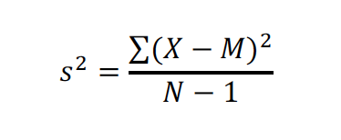

*Where (N-1) = df*

* **Characteristics of Estimators**
  + Bias – whether an estimator tends to over or underestimate the parameter
    - Statistic is biased if long-term average value of the stat is not the parameter it is estimating
    - If mean of the samp dist of statistic is not equal to the parameter
      * Mean 🡪 “expected value of the statistic”
    - The mean of the sampling distribution of the sample mean is the population mean miu 🡪 sample mean is an unbiased estimate of miu
    - Variability: if N is used for sample var, then estimates tend to be too low and thus biased

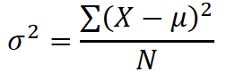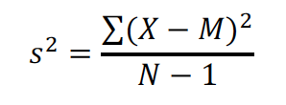

* + Sampling variability – how much the estimate varies from sample to sample
    - How much a statistic varies from sample to sample 🡪 usually measured by SE
    - Smaller SE = smaller sampling var
    - Larger sample size = smaller SE of mean = lower sampling var

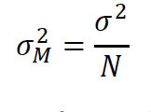

* + - The relative efficiency of 2 stats is defined as ratio of SE, OR satio of squared SE
    - Stats differ in sampling var even w same sample size
    - *bias and variability simulation
* **Confidence Intervals** 
  + **Introduction**
    - Confidence intervals provide more information about point estimates (eg take a sample weight of 10 yr old child—how do you know other children weigh the same?)
    - 95% or 99% CI
    - Eg population mean lies between 2 bounds
    - Interpretation:
      * Each interval is symmetric about the point estimate
      * Each interval is contiguous
      * Probability is sometimes subjective
      * Natural to interpret a 95% CI as interval w 0.95 prob of containing pop mean, but not always the case
  + **Confidence Interval for the Mean**
    - Standard error of the mean:
      * 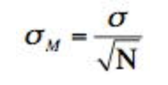
      * 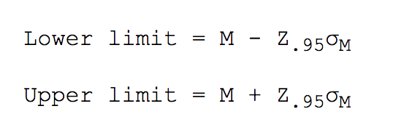
      * Where Z.95 is the # of SD extending from the M of a normal dist required to contain 0.95 of the area
      * SigmaM = SE of mean
      * Need SD to estimate mean
      * 🡪 using the calculator to find Z.95
      * Then compute confidence interval:

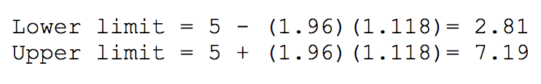

* + - * use t dist when var is unknown and has to be estimated from sample data ; t dist similar to normal when sample size is large > 100
        + but when N is small, t dist is **leptokurtic** = relatatively more scores in tails that normal dist
    - Finding t for confidence interval desied
      * Compute sample mean and var
      * Estimate SE of mean
        + Or compute estimate of SE
      * Find the value of t
        + Using the table
      * Compute confidence interval using SDm
    - Stroop Data analysis
      * Interference effect (difference) likely between 2 points
* **t Distribution**
  + eg if you have a normal distribution but you don’t know the standard deviation
  + Student’s t distribution – the distribution of a mean divided by its estimate of the standard error
  + 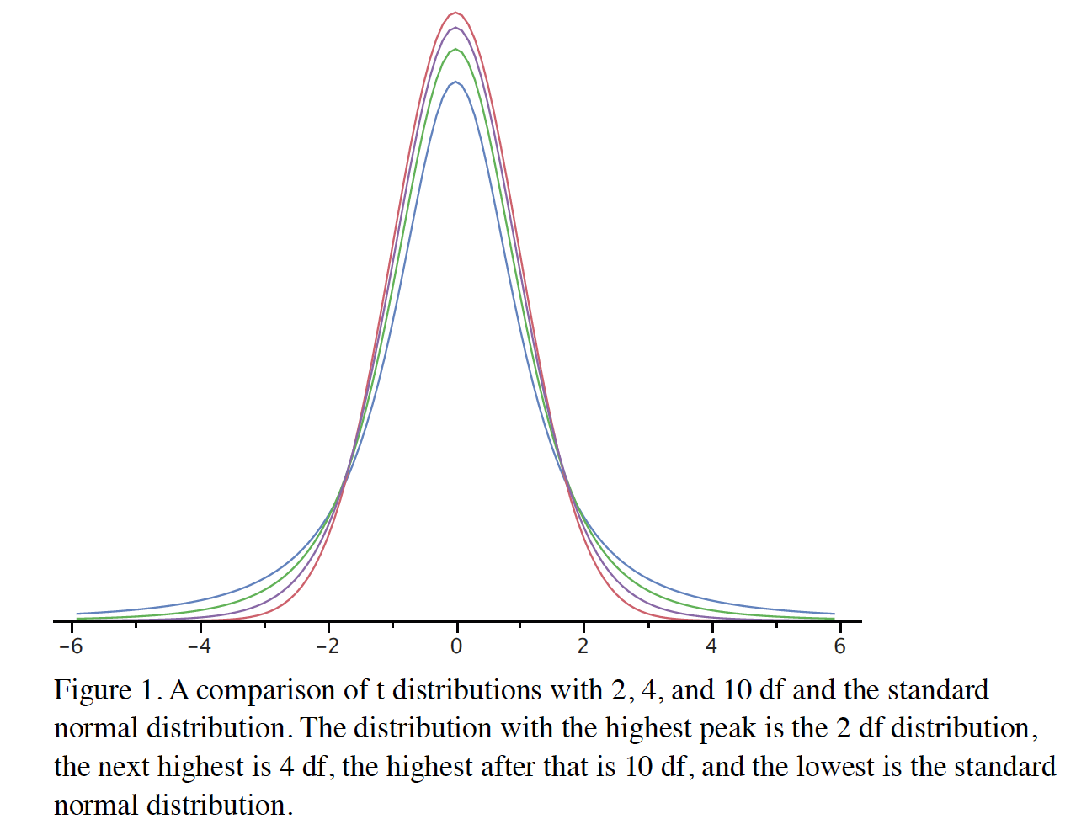
  + Normal dist has more scores in the center of the dist while t dist has relatively more in the tails
    - Leptokurtic
  + T dist approaches normal dist as the degrees of freedom increase
  + *Confidence interval simulation
* **Confidence Interval for the Difference Between Means**
  + Difference in sample means is used to compute the difference in population means 🡪 the accuracy of the estimate is revealed by a confidence interval
  + Assumptions for constructing confidence interval:
    - Both populations have same variance (homogeneity of variance)
    - Both populations normally distributed
    - Each value sampled independently from each other value
    - 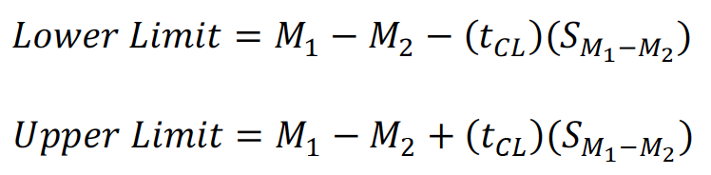
  + Steps for computing CI:
    - Compute estimate of SE of the diff between means
      * 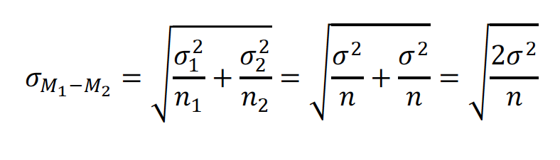
      * To estimate the above, estimate the var and use that estimate in place of the actual variance. You can use the below formula;
        + 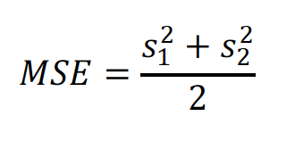
        + MSE = estimate of variance = mean squared error
    - Find the t to use for the confidence interval
      * Need to know degrees of freedom
        + “the number of independent estimates of the var on which MSE is based”
        + *df* = (n1 -1) + (n2 -1) where n is sample size
    - use the t-table to find the confidence (95%) interval for t
      * then compute the lower limit and upper limit confidence intervals
  + Formatting data for computer analysis
  + Computations for unequal sample sizes
    - MSE counts the sample with the larger sample size more than the sample with the smaller sample size
    - Sum of Squares Error
      * 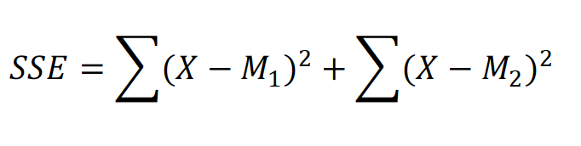
      * 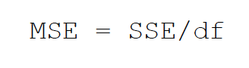
      * 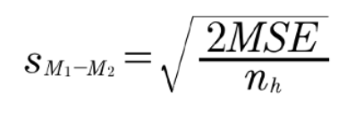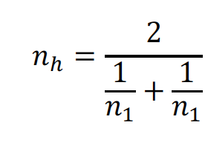
* **Confidence Interval for Pearson’s Correlation**
  + Steps:
    - Convert r to z’
    - Compute a confidence interval in terms of z’
    - Convert the confidence interval back to r
  + Sampling dist of z’ is approximately normally distributed, so the standard error is
    - 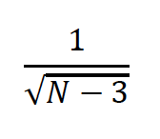
* **Confidence Interval for a Proportion**
  + The confidence interval is computed based on the mean and standard deviation of the sampling distribution of a proportion, using the below formulas:
    - 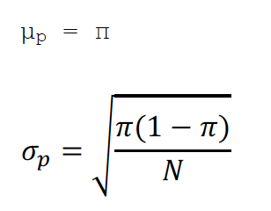
    - We can use the sample proportion p to estimate the population parameter pi
    - 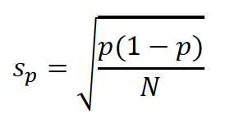
  + Then we take p and create an interval that ranges (Z.95)(sp) in both directions
    - Note that the value for Z is computed with the normal calculator = 1.96
  + Because we are approximating a discrete distribution with a continuous distribution, subtract 0.5/N from lower limit and + 0.5/N to upper limit:
    - 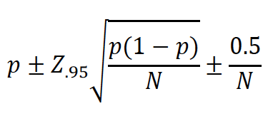
* **Statistical Literacy**

**Chapter 11: Logic of Hypothesis Testing**

* **Introduction**
  + Could the finding have occurred by chance?
    - Eg was it just luck?
  + Binomial distribution
  + Hypothesis: James Bond was guessing whether the drink was stirred or shaken
  + Case Study: physician’s reactions
    - How might the difference between means have occurred?
      * Random assignment does not ensure the correct analysis
      * Eg the 2 groups might have differed in more ways
    - **The Probability Value**
      * What do probability values mean?
        + “ In the James Bond example, the computed probability of 0.0106 is the probability he would be correct on 13 or more taste tests (out of 16) if he were just guessing.”

The probability 0.0106 is the prob of a certain outcome assuming a certain state of the world

It is *not* the probability that a state of the world is true

* + - * + Probability of the outcome, and NOT the state of the world

Hypothesis = stats of the world

Probability of an outcome given the hypothesis

NOT the probability of the hypothesis given the outcome

Bayesian statistics = methods for computing the probabilities of hypothesis

* + - **The Null Hypothesis** 
      * Hypothesis that an apparent effect is due to chance = null hypothesis
      * Usually that the value of a parameter = 0
      * Typically the opposite of the researcher’s hypothesis
      * Alternative hypothesis = the reverse of the null hypothesis
* **Significance Testing**
  + Low probability value = casts doubt on the null hypothesis
    - Null is false if the probability value is less that 0.05
    - Alpha level = the probability value below which the null hypothesis is rejected
      * Also called the significance level
    - When null is rejected = effect is said to be statistically significant
      * Statistical significance means only that the null hypothesis of exactly no effect is rejected 🡪 does not mean that the effect is important
      * Statistical significance is not practical significance
    - Approaches for significance testing:
      * R Fisher – significance test conducted and the prob value reflects the strength of evidence *against* the null
        + If prob below 0.01, data shows strong evidence that null is false
      * Neyman & Pearson – specify level a before analyzing the data
        + If analysis results in probability value below a then null is rejected
        + If it is not, then null hypothesis is not rejected
        + More of significant and not significant, but doesn’t matter *how* significant or how close to significant
      * R-Fisher approach is what will be used here
* **Type I and II Errors**
  + Type I = occurs when a significance test results in the rejection of a true null hypothesis
    - Affected by alpha level
      * The lower the alpha, the lower the type 1 error rate
      * Alpha = probability that type 1 error will occur given that the null hypothesis is true
        + If null hypothesis is false then it’s impossible to make type 1 error
  + Type II = failing to reject a false null hypothesis
    - Lack of significance does not support the conclusion that the null is true
    - Eg when a test was not statistically significant
    - Can only occur when null is false
    - Beta
    - Probability of correctly rejecting a false null is 1-B (power)
* **One and Two Tailed Tests** 
  + One-tailed probability = probability calculated in only one tail of the distribution
  + 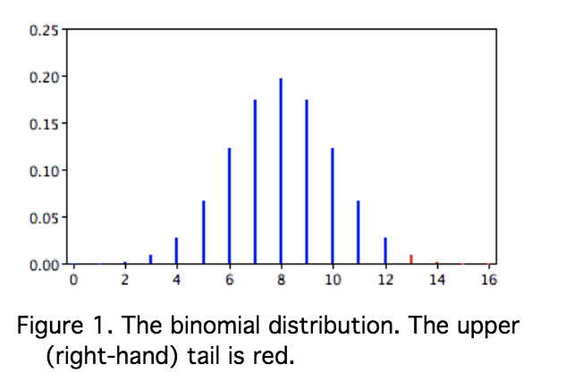
  + “What is the prob of getting a result as extreme as or more extreme than the one observed?
    - Consider both tails of the distribution
  + Two-tailed probability
  + 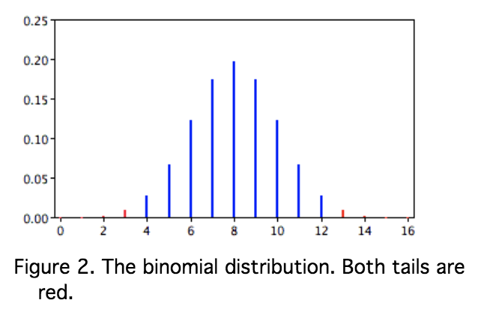
* **Interpreting Significant Results**
  + When probability value is below alpha, the effect is statistically significant and the null hypothesis is rejected
  + The alternative hypothesis is accepted when the null hypothesis is rejected
    - The direction of the sample means determines which alternative is adopted
* **Interpreting Non-Significant Results**
  + Accepting the null hypothesis – concluding that it is true 🡪 this is an error 🡺 do not accept the null hypothesis when you do not reject it
  + Generally impossible to prove a negative
* **Steps in Hypothesis Testing**
  + Specify the null hypothesis
    - 2 tailed = typically a parameter = 0
    - 1 tailed =parameter is > < 0
  + Specify the alpha level (or significance level) 🡪 usually 0.05 or 0.01
  + Compute the probability value (or p value)
    - Probability of obtaining a sample statistic as different or more different from the parameter specified
  + Compare the probability value with alpha
    - If p < a then reject the null
    - Lower p = more confidence that null is false
* **Confidence Intervals** 
  + Relationship between confidence intervals and significance testing
  + Every value in the CI is a plausible value of the parameter
* **Misconceptions** 
  + The probability value is the probability that the null hypothesis is false
    - The probability value is the probability of a result as extreme or more extreme given that the null hypothesis is true. It is the probability of the data given the null hypothesis. It is not the probability that the null hypothesis is false.
  + Misconception: A low probability value indicates a large effect.
    - Proper interpretation: A low probability value indicates that the sample outcome (or one more extreme) would be very unlikely if the null hypothesis were true. A low probability value can occur with small effect sizes, particularly if the sample size is large.
  + Misconception: A non-significant outcome means that the null hypothesis is probably true.
    - Proper interpretation: A non-significant outcome means that the data do not conclusively demonstrate that the null hypothesis is false.
* **Statistical Literacy**

**Chapter 12: Testing Means**

* **See notebook**

**Other Resources:**

**Hypothesis Testing (from dad)**

* [**https://www.youtube.com/watch?v=VK-rnA3-41c&feature=youtu.be**](https://www.youtube.com/watch?v=VK-rnA3-41c&feature=youtu.be)
* Hypothesis
  + a premise or claim that we want to test or investigate
* Null Hypothesis
  + 0 , empty
  + Default hypothesis (established)
  + H0 🡪 currently accepted value for a parameter
* Alternative Hypothesis
  + Ha 🡪 research hypothesis
  + Involves the claim to be tested
* H0 and Ha are mathematical opposites
* Possible outcomes of this test?
  + Reject the null hypothesis
  + Fail to reject the null hypothesis
* Test statistic
  + Calculate from sample data used to decide
  + Ex) sample 50 bars
    - Get avg val
    - Calculate test statistic
* Statistically significant – where do we draw the line to make a decision?
* Level of confidence
  + C – 95%, 99%
  + How confident are we in our decision?
* Level of significance
  + Alpha = 1-C
  + So LOC = 95%
  + C = 0.95
  + Alpha = 1-0.95
  + Alpha = 0.05
* Confidence intervals
  + Means
    - < 30 🡪 t dist
    - >= 30 🡪 normal dist
  + Proportion
    - Normal
  + SD / Var
    - Chi squared

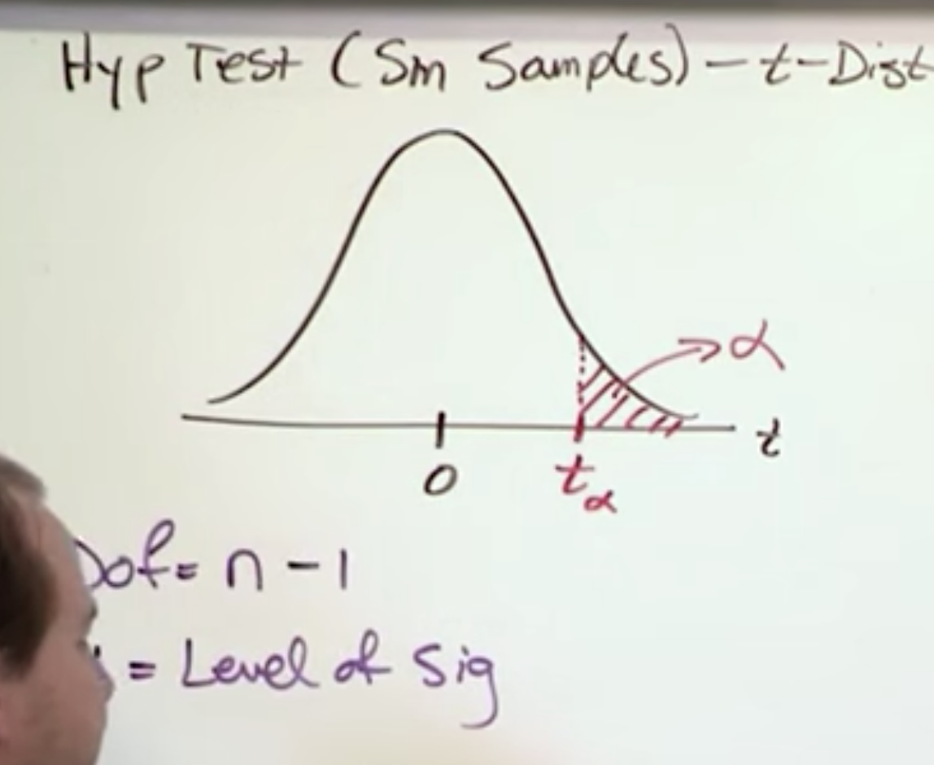

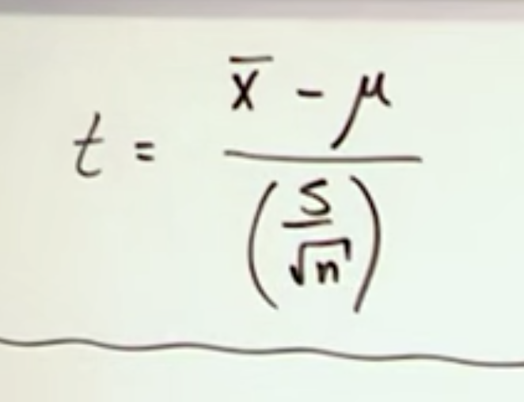

**Tests of Means**

* <https://www.youtube.com/watch?v=NQWZefn41VY>
* Hypothesis testing – single sample t-test
* 2 types:
  + Given SD
  + Not given SD

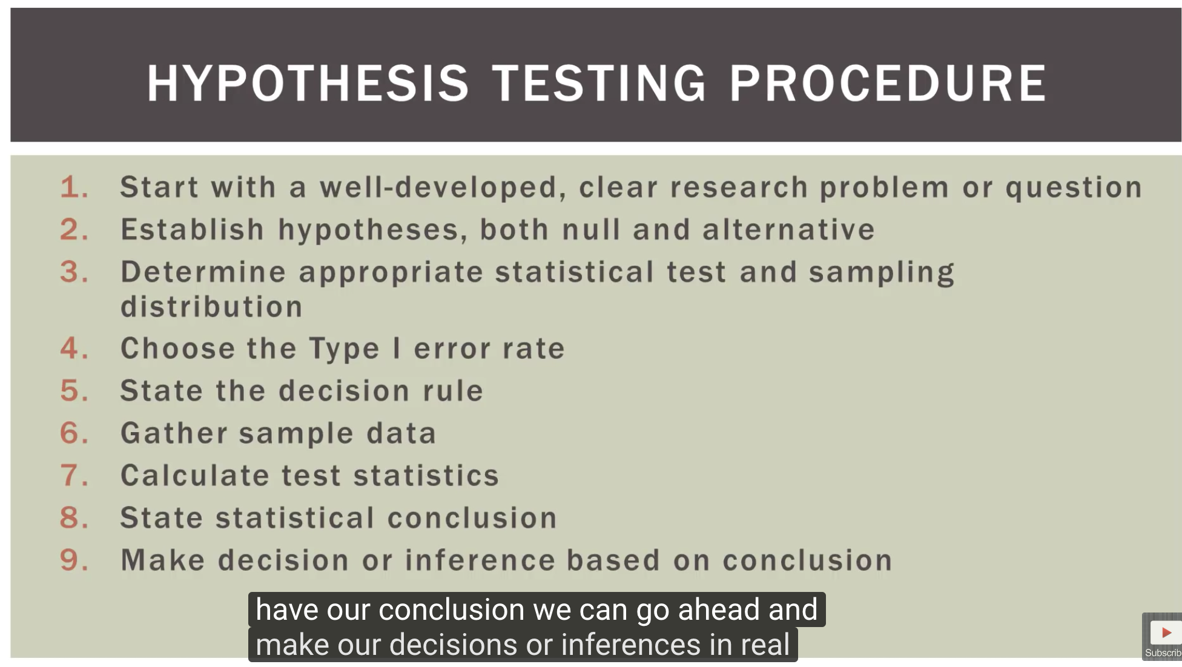

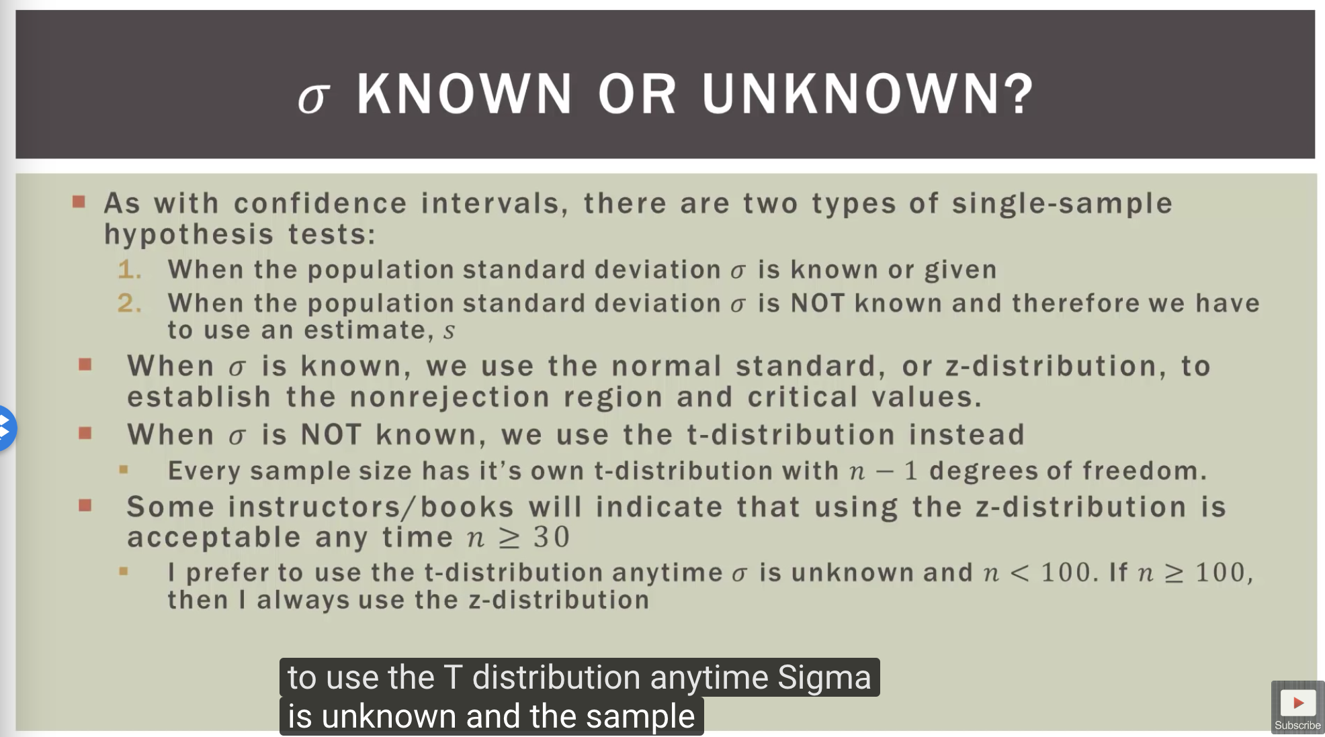

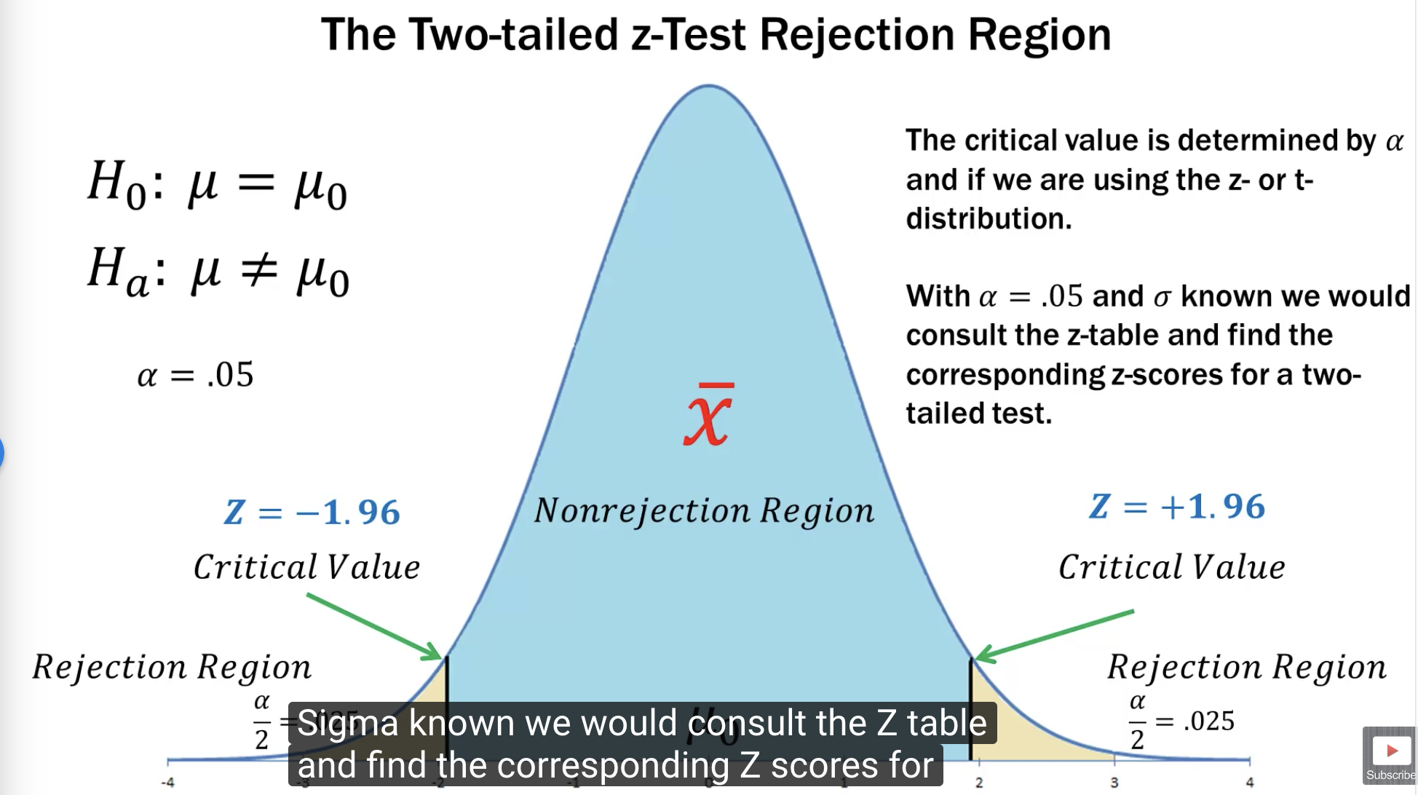

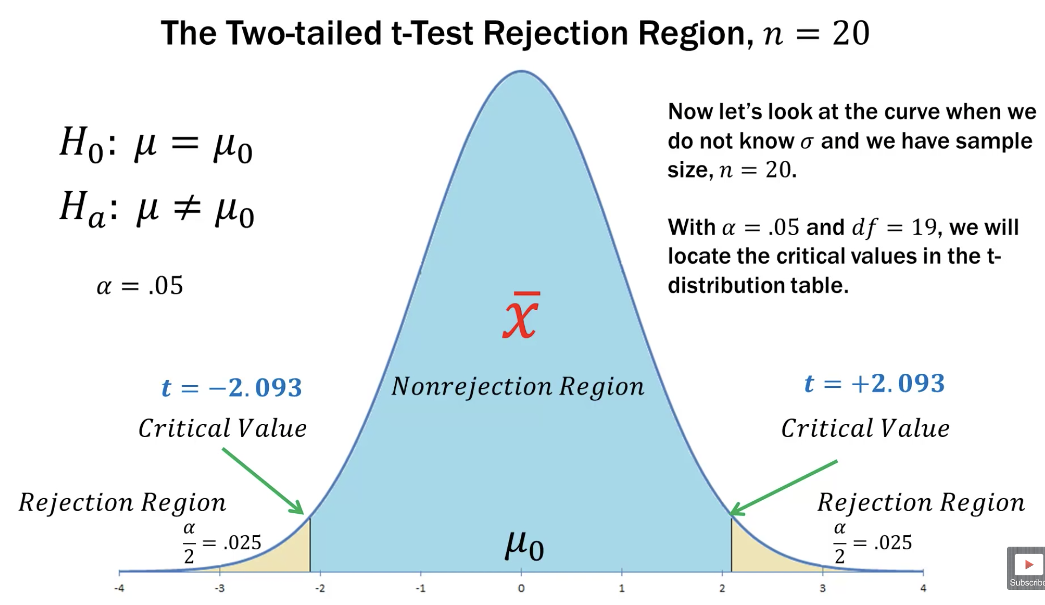

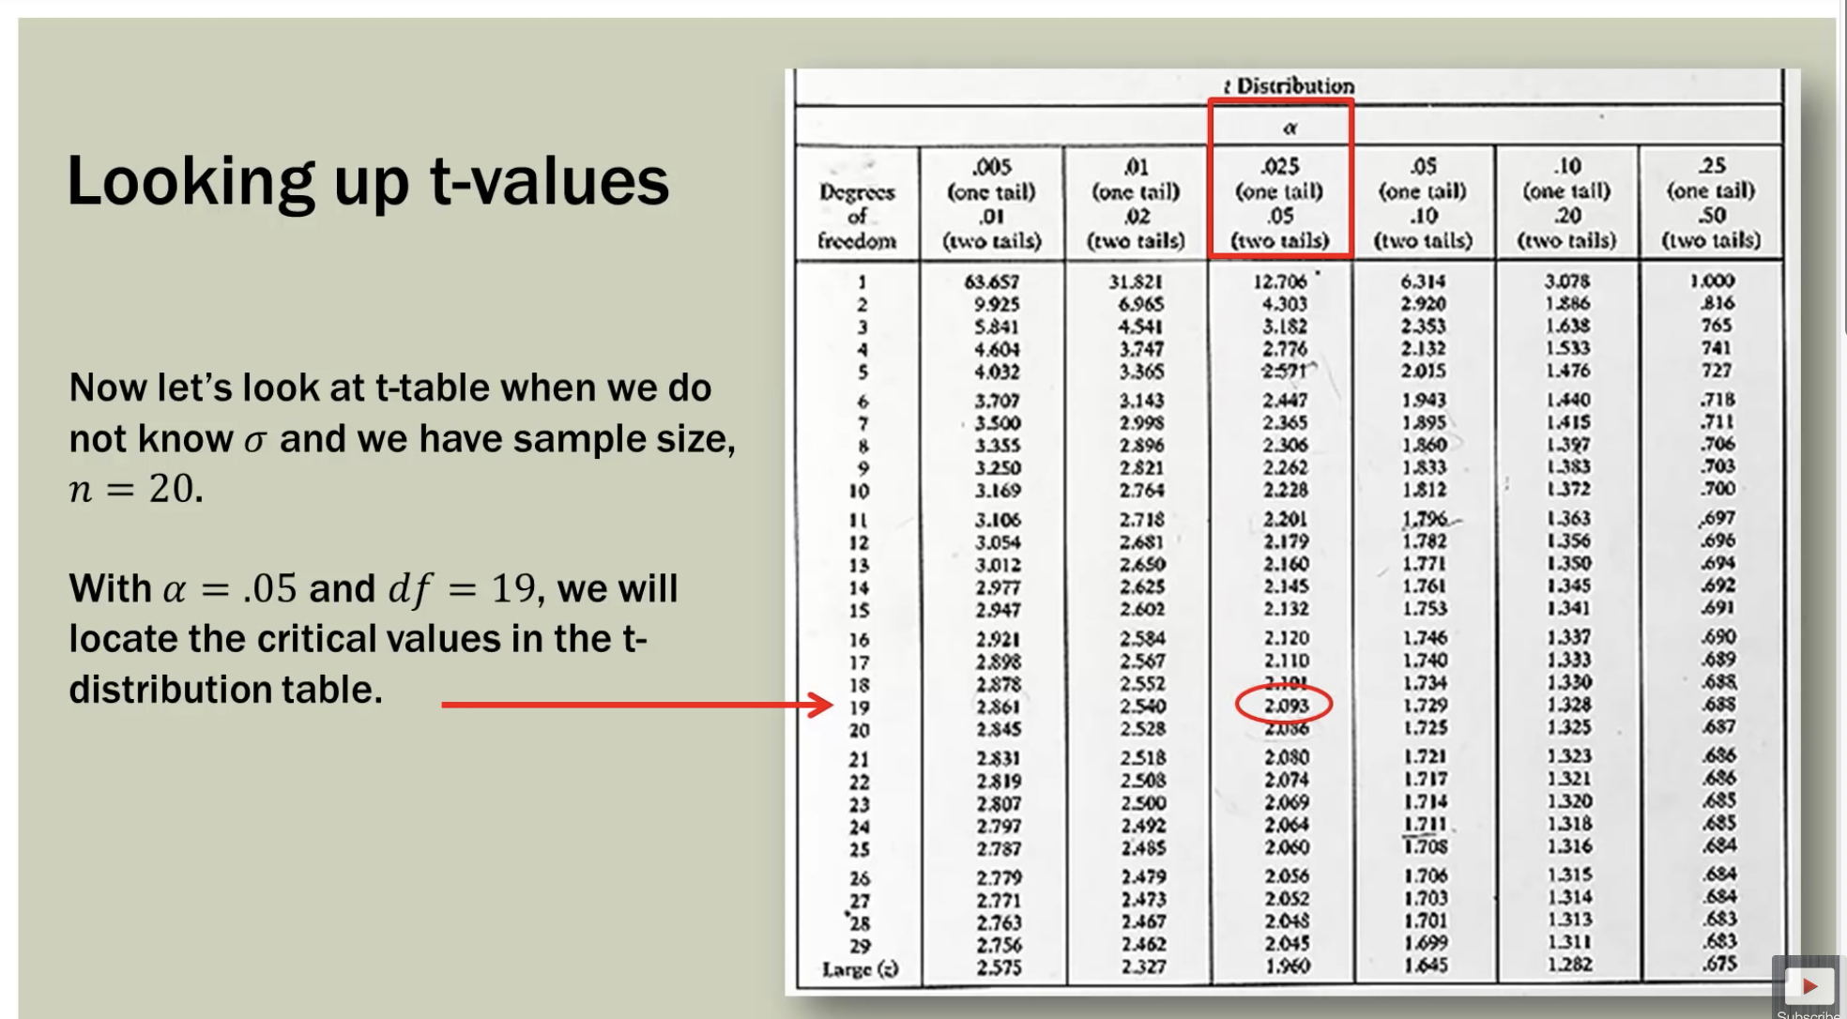

<https://www.youtube.com/watch?v=N984XGLjQfs>

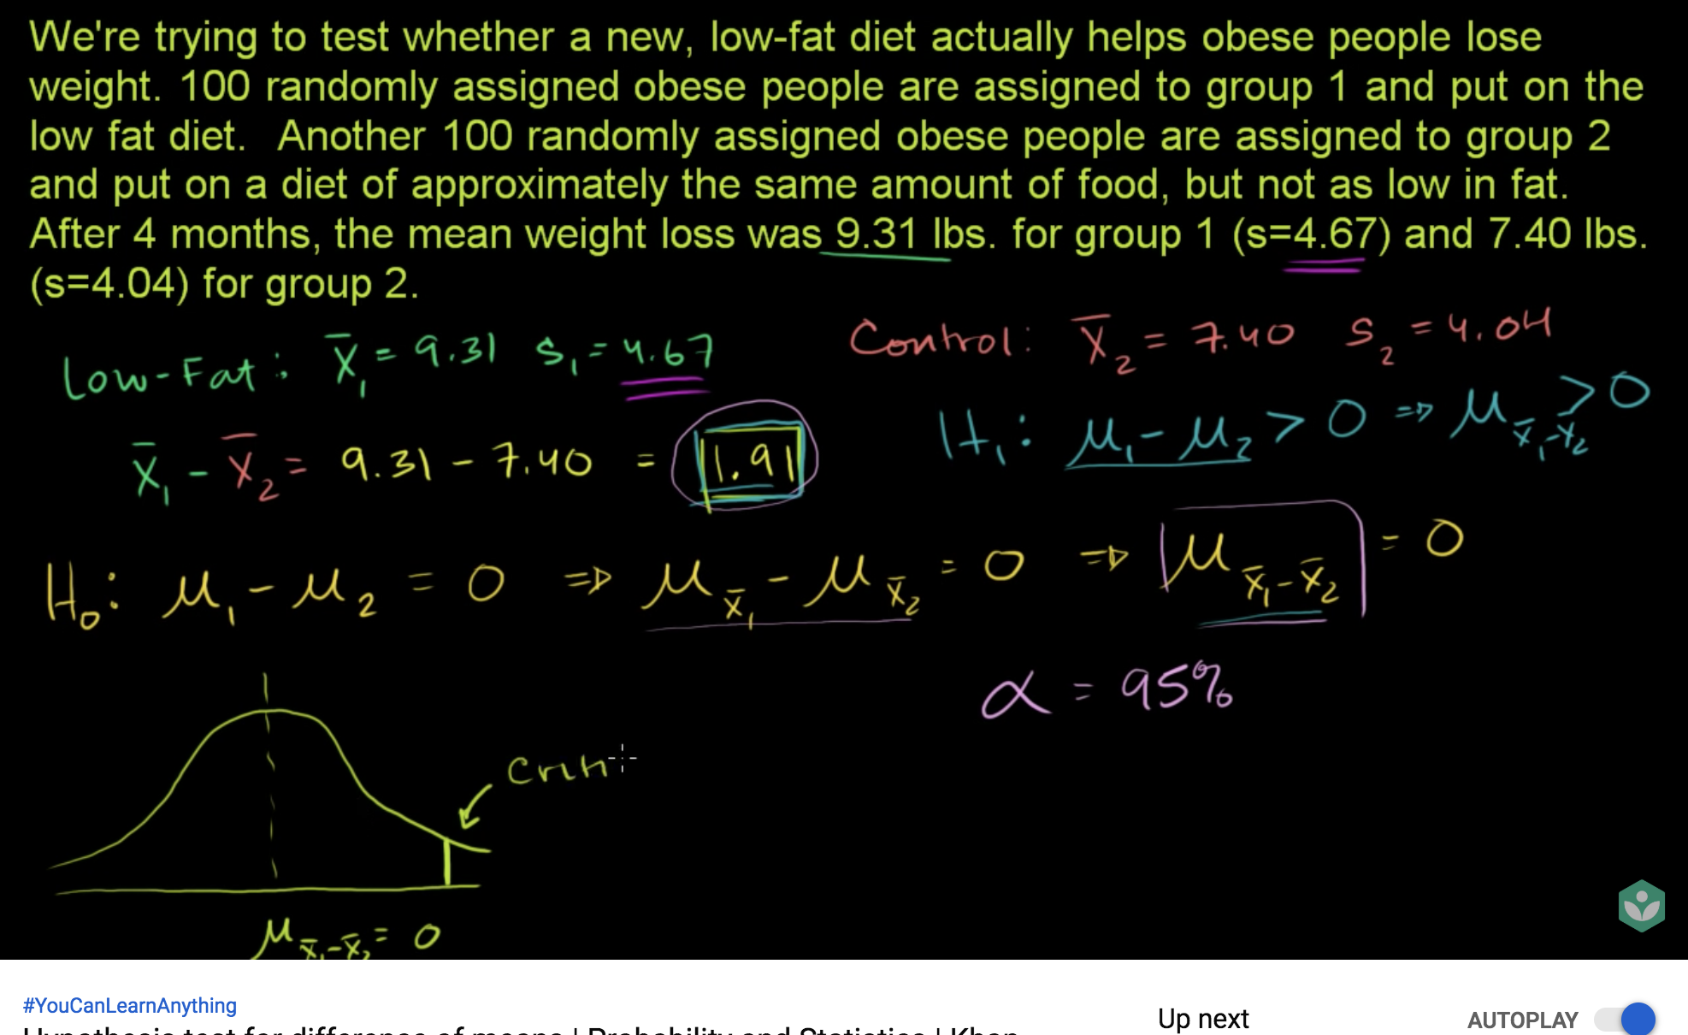

<https://www.youtube.com/watch?v=KTFm7El1NBs>

hypothesis testing for 2 means

* Independent sample
* Dependent sample